Practical - 7

PHP Form Processing with Server-Side Validation and CSV/JSON File Storage

Process submitted registration/contact form data using PHP. Validate and sanitize inputs on the server side and store records in CSV or JSON file format. Display success/error messages.

Theory
  - Is the form submitted using POST? Answer :
Yes. Both the register.html and contact.html forms were updated to include method="POST" to securely send data to the PHP scripts without exposing data in the URL.

  - Are inputs validated and sanitized server side? Answer :
Yes. Email fields are validated using PHP's built-in filter_var($email, FILTER_VALIDATE_EMAIL). Text inputs are thoroughly sanitized to prevent Cross-Site Scripting (XSS) by combining trim(), strip_tags(), and htmlspecialchars().

  - Is file writing handled safely? Answer :
Yes. The script first checks if the DATA directory exists and creates it if it doesn't. When writing to the CSV, it uses fopen($file_path, 'a') to append data safely without overwriting previous records. When writing to JSON, it correctly retrieves the existing data, decodes it, pushes the new record, and encodes it back using file_put_contents.

  - Are success and error responses displayed clearly? Answer :
Yes. After processing, the script outputs a styled HTML response. Depending on a $success boolean, the message text color changes dynamically (green #4CAF50 for success, red #f44336 for errors), clearly informing the user of the outcome.

Implementation
Transitioned the project from purely frontend to full-stack. Configured forms in register.html and contact.html to send POST requests. Created process_register.php (which sanitizes data and saves to a .json file) and process_contact.php (which sanitizes data and appends it to a .csv file).

Evidence of Work (Screenshots)
- entry stored
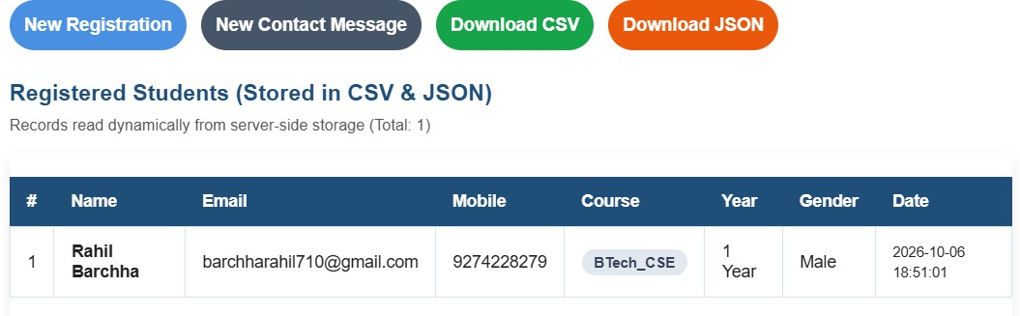
- contact form
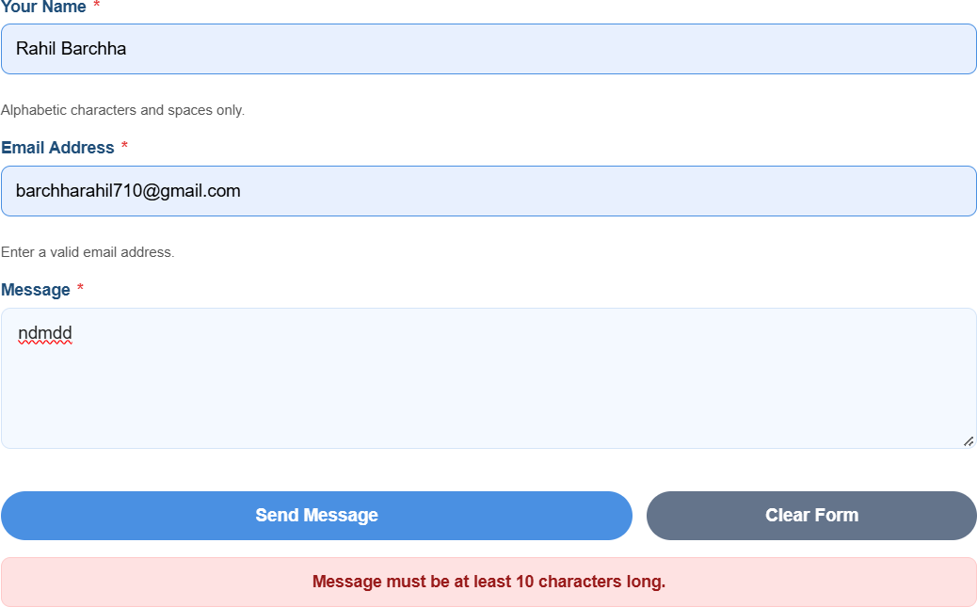

- registration details
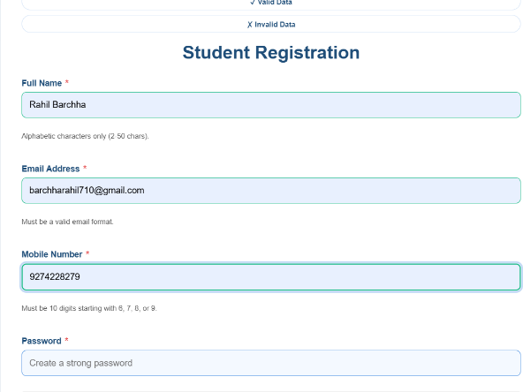
- feedback
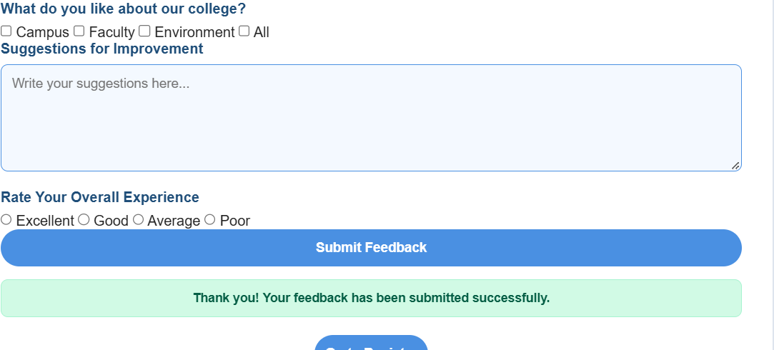

- GitHub Repository Link: https://github.com/RahilBarchha/student-hub-.git

Challenges Faced:
- Understanding the bridge between the frontend (HTML forms) and the backend (PHP $_POST array).
- Dealing with server environments (XAMPP/Apache) and figuring out file permission issues (chmod 777 on macOS) so that PHP had the correct read/write access to create the DATA directory and the JSON/CSV files.
- Ensuring security by heavily sanitizing inputs (htmlspecialchars, strip_tags, FILTER_SANITIZE_EMAIL) to prevent XSS (Cross-Site Scripting) attacks.

Learning Outcomes:

Mastered the fundamentals of Backend Web Development: handling HTTP POST requests, server-side data sanitization, file I/O operations in PHP (working with fopen, fputcsv, and json_encode), and running a local server environment (XAMPP).

